**KIET Group of Institutions, Ghaziabad**

## Department of Computer Applications

**(An ISO – 9001: 2015 Certified & ‘A’ Grade accredited Institution by NAAC)**



OOPS LAB (KCA-251)

**(Session 2021-22)**

**COURSE-MCA**

**SEMESTER – 2**

**SUBMITTED TO : SUBMITTED BY : Dr. Vipin Kumar Rajul Sahu**

1. **Write a Java program to insert 3 numbers from keyboard and find out greater number among 3 numbers.**

import java.util.*;

public class GreatestNumber {

    public static void main(String[] args) {

        Scanner sc = new Scanner(System.in);

        int a = sc.nextInt();

        int b = sc.nextInt();

        int c = sc.nextInt();

        First obj = new First();

        int res = obj.findGreatest(a, b, c);

        System.out.println(res + "is greatest");

    }

}

class First {

    public int findGreatest(int a, int b, int c) {

        int max = (a > b) ? (a > c) ? a : c : (b > c) ? b : c;

        return max;

    }

}

OUTPUT :- 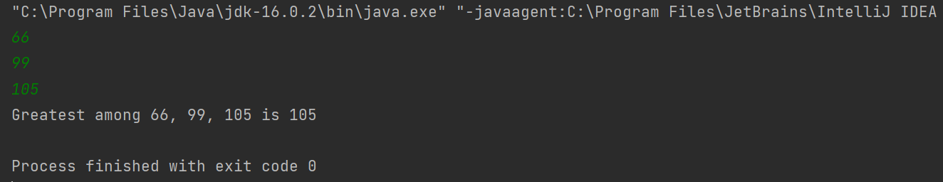

**2. Write a Java program to find out the sum of command line arguments.**

public class Second {

    public static void main(String[] args) {

        Compute obj = new Compute();

        int res = obj.findSum(args);

              System.out.println("sum = " + res);

    }

}

class Compute {

    public int findSum(String[] args) {

        int sum = 0;

        for (int i = 0; i < args.length; i++) {

            sum += Integer.parseInt(args[i]);

        }

        return sum;

    }

}

OUTPUT :-

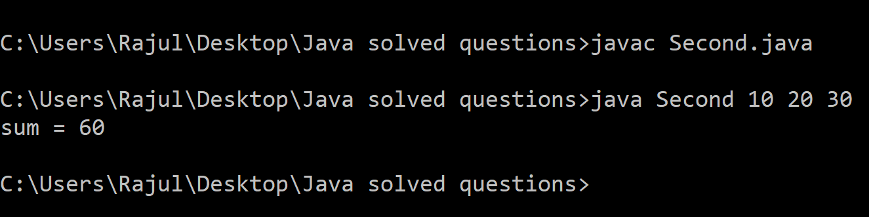

**3.  Write a Java program to create a Room class, the attributes of this class is roomno, roomtype, roomarea and ACmachine. In this class the member functions are setData and displayData. Use member function to set data and display that data using displayData() method.**

class Room {

    int roomNo;

    String roomType;

    double roomArea;

    boolean ACMachine;

    Room(){

        this.roomNo = 0;

        this.roomType = "";

        this.roomArea = 0.0;

        this.ACMachine = false;

    }

    void setData(int rn, String rt, double ra, boolean ac){

        this.roomNo = rn;

        this.roomType = rt;

        this.roomArea = ra;

        this.ACMachine = ac;

    }

    void displayData(){

        System.out.println("Room Type: " + this.roomType);

        System.out.println("Room Area: " + this.roomArea);

        System.out.println("Room Number: " + this.roomNo);

        System.out.println("AC Machine: " + this.ACMachine);

    }

}

class Third {

    public static void main(String[] args) {

        Room room = new Room();

        room.setData(201, "Single", 400.0, true);

        room.displayData();

    }

}

OUTPUT :-

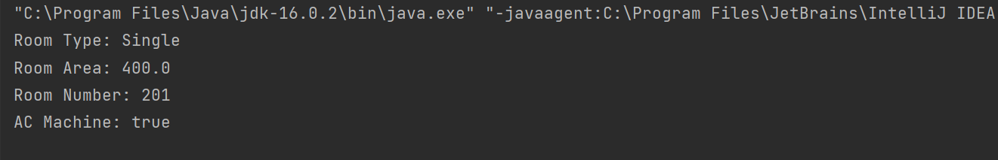

**4.  Write a Java program to create a class “SimpleObject” and display message by using constructor of this class.**

public class Constructor {

    public static void main(String args[]) {

        Fourth obj = new Fourth();

    }

}

class Fourth {

    Fourth(){

        System.out.println("Object is Created, default constructor called..");

    }

}

OUTPUT :-

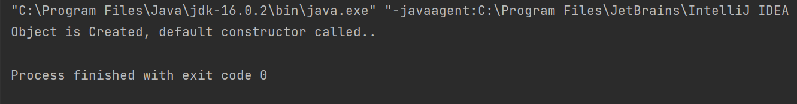

**5.   Write a program to demonstrate static variables, methods, and blocks.**

public class StaticDemo {

    public static void main(String[] args) {

        Fifth.displayCount();

        Fifth.increaseCount();

        Fifth.increaseCount();

        Fifth.increaseCount();

        Fifth.increaseCount();

        Fifth.displayCount();

    }

}

class Fifth {

    static int count = 0;

    static void increaseCount() {

        count++;

    }

    static void displayCount() {

        System.out.println(count);

    }

}

OUTPUT :-

